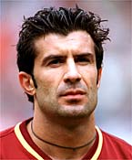
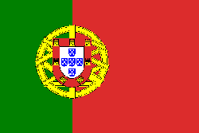
Full name: Luís Filipe Madeira Caeiro
Date of birth: 4th November 1972
Birthplace: Almada, Portugal
Nationality: Portuguese
Height: 180 cm
Weight: 75 kg
Club: FC Internazionale Milano
Position: Attacking Midfielder
Contract Expires: June 2007
Previous Clubs: Sporting Lisbon → Barcelona → Real Madrid → Inter Milan
National team: Portugal

competition | games | goals | yellow card |  |  | red card | exchange |  | play minutes
 |  |  |  |  |  |  | in | out | play minutes
Series A | 34 | 5 | 3 | - |  | - | 6 | 15 | 2482
Champions-League | 8 | 1 | 2 | - |  | - | - | 5 | 627
world championship | 1  +1  WM 2006 | - | - | - |  | - | - | - | 90
Total | 43 | 6 | 5 | - |  | - | 6 | 20 | (53h 19 min)  3199
yellow-red
card

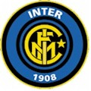
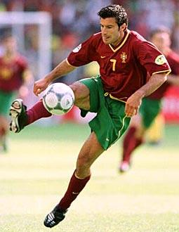
Luís Figo is one of the famous Portuguese football player. He is the record national player of Portugal. He has won many rewards, e.g. he became to the “European Footballer player of the Year” 2000 and to the “FIFA World Player of the Year” 2001. In 2004 he was the 2nd European campion of the European championship. Till summer 2005 he has played for “Real Madrid”.Totime he plays in the football club “Intern Mailan”. “Inter Milan” is a traditraditional Italian football club. When he was 17 years old he played for the first time in a Portuguese football championship with “Sporting Lissabon”. With 19 years he was internationally well-known. At 18th August 2004 he resignated from the Portuguese national team, but at 4th June 2005 come back to the national team, because the successfuly qualification game for the world championship 2006 in Germany. Today he has a market value from 13.000.000,- €. His graduation is school-leaving examination.

